Compete Documentation

AVR 2006 Design Contest
Entry registration number: AT3283
Entry title: Positional Sensor Interface
Product: AVR ATmega16 using the STK500 Starter Kit

Copyright 2006 by Chuck Baird, http://www.cbaird.net
All rights reserved

Description

Purpose
The purpose of this project was to develop a low cost sensor interface for use in homebrew robotics. The author has always been impressed with the concept and implementation of optical mice and their reasonable price (under $10), and thought that the switches, scroll wheel, and XY optical sensor of a mouse could easily be utilized in under funded, seat-of-the-pants robotics. Since the reliability of mouse hardware is well established, all that would be needed would be something that simplified the rather arcane mouse/host communication.

The idea was to put a microcontroller between the mouse and host system, have the microcontroller worry about the ins and outs of mouseland, and, on the other side, play nicely with the host. The author could imagine mouse parts (switches, scroll wheel, and XY sensor) being utilized throughout his various projects, with a simple communications protocol to access them.

The development process
The ATmega16 (8 MHz clock) and STK500 Starter Kit were chosen primarily because the author already owned them. The STK500 had an easily accessible spare RS-232 interface, so RS-232 (19.2K) was chosen as the method of interface/host communication. A more practical solution for a “production” version would have been one of the several digital I/O choices available since the host in most applications would likely be another microcontroller. However, with the RS-232 line being available and greatly simplifying the debugging process (via terminal software), the standard serial interface won. It had the added advantage of allowing testing of the interface via terminal once it was finished.

As the idea to interface a mouse gained momentum, it became obvious that overkill should prevail since a herd of mice couldn’t help but be better than one. However, having a dedicated interrupt line for each mouse simplified the design, and as the ATmega16 has three interrupt lines, the decision was made to design the interface for three mice. Thus no additional decoding hardware was necessary (even more mice could be supported with minimal interrupt contention circuitry). An added benefit was that PS/2 mice could connect directly to the AVR I/O pins, so in fact no additional hardware at all was required (other than the RS-232 level drivers which were included in the STK500).

With three mice, the interface could monitor 9 switches, 3 scroll switches, and 3 optical XY sensors, while using only 6 of the 32 AVR I/O lines. This seemed like a waste of real estate, so the interface was expanded to include direct control of all the I/O lines at no additional cost. The host can read and write any of the pins on the AVR via the interface. A final touch was allowing individual mouse switches to be optionally linked to the I/O pins, so that for example a switch closing could toggle, set, or reset one of the pins.

The STK500 conveniently provided all the support circuitry needed for this project, minimal as it is. As described later, one of the demonstrations used the STK500 LEDs and switches to show how the interface could manipulate the AVR I/O pins for connecting with other hardware, but the LEDs and switches were not part of the interface. An external 5vdc power supply was used to power the mice, since it wasn’t clear how much power could be safely drawn from the STK500 for the mice, nor what current the mice actually drew.

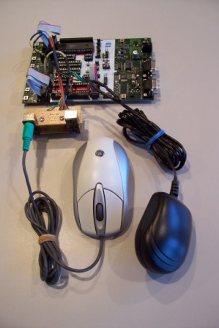
The Mousie Project
The STK500, one mouse, power supply for mice, and
four PS/2 connectors scavenged from a KVM switch.

Once the decisions were made for RS-232 serial I/O to the host, and three (versus more) mice, a choice of languages was made. Actually, no choice was involved because the author does not own an AVR compatible C compiler, is too cheap to buy one, but does have a copy of the (very nice) AVR Studio 4 with assembler. The author was several years beyond his last serious assembly language programming and was unfamiliar with the AVR architecture, instruction set, and RISC mindset, so the learning curve was initially vertical. It soon leveled out, fortunately, with a minimum of pain.

One of the first software design dilemmas was deciding between polled and interrupt driven I/O at the lowest level for both the interface/host and interface/mice communication links. It became obvious quickly that the reasonable solution was for both to be interrupt driven, and that the mouse communications be flexible enough to support any number of mice since additional hardware could add more. A related question was whether the mice should continuously stream data to the interface or wait for requests (polling lost again). Finally, there was the question of whether the host should request data from the interface or receive it asynchronously (polling won).

The project proceeded in stages, with bringing up the RS-232 interface being the first step. One problem was that the ATmega16 manual’s baud rate number for the USART was incorrect (at least for this chip in this development system with this internal clock and speed configuration). A self calibrating routine was written that allowed an automated trial and error determination of the proper parameter and solved a frustrating problem. Once the STK500 could talk things got easier.

The next problem was learning to speak mouse-ese. The author was greatly indebted to Adam Chapweske (http://www.computer-engineering.org) for his fine articles on the PS/2 mouse interface and protocol, and of course to Al Gore for inventing the internet so Mr. Chapweske could be located. Mice use a serial protocol and always supply the clock, and they recognize over a dozen commands. Both interface and mice manipulate both the clock and data lines during a dialog, so implementing the communications was interesting.

During the initialization sequence the interface/mouse conversation is two way. In general the expected responses of the mouse are known in advance and, if not received, indicate an error condition. Once initialized the mouse starts an asynchronous monologue (as implemented here) and streams data packets of three or four bytes, depending upon the mouse type. While mice are capable of other flexibilities, these were not incorporated in this initial version of the interface.

Situations where errors (other than unexpected responses during initialization, which were easy to identify) could occur include:
The interface requests to talk to a mouse, but the mouse doesn’t respond. This would usually arise from attempting to initialize a non-existent mouse.
The time between individual clocking bits (communication in either direction) was too long. The mouse always supplies the clock, so hopefully this would not be a problem.
The total time to send or receive a byte (from start bit to stop bit) was too long.
The time to receive a complete packet (3 or 4 bytes) was too long.
The time between successive packet bytes was too long.
The received byte had parity errors.
The packet contents were bad (invalid header byte).

As long as the interface doesn’t issue commands to the mouse, the mouse should send only packets (it’s capable of a few other grunts and groans but generally keeps quiet). Unfortunately, since packets are multi-byte, it is possible for things to get unsynchronized. Worst yet, the interface would not know if a mouse existed without initializing it, and could not initialize it unless it existed. Without a missing mouse’s pullup resistors, checking the state of the I/O pins was unreliable. Some sort of error recognition and recovery had to be devised, and ideally a mechanism for monitoring packets could be implemented.

These problems were addressed using one of the AVR 8 bit timers. It was set to interrupt once per millisecond, and three timing mechanisms were implemented for each mouse. The three mechanisms time the mouse’s response to a request from the interface to send and total byte transmit/receive times, the total time for a packet reception, and the time between the reception of successive packet bytes. Initially set values count down on each interrupt, and a count of zero represents a timing error.

Parity errors in bytes received from the mice were ignored, since to do otherwise would require retransmission requests which were outside the first pass of sophistication. Likewise, receive errors (bad packet headers and all types of timing errors) cause the entire packet to be discarded. This is less than ideal, since of course retransmission should first be requested for graceful and lossless recovery. As a compromise, the host may request a count of rejected packets from the interface.

The next step was getting one way serial PS/2 communications going. For this a PS/2 keyboard was used (they use a similar protocol to a mouse) since keyboards initiate communication while the shy and coy mice require coaxing via an Enable command. Once this worked then full duplex was achieved and the mouse initialization code was added, complete with mouse type determination (normal, scroll, Intellimouse). Since currently most new inexpensive mice are scroll mice, the Intellimouse is supported but only to the same extent as a scroll mouse (i.e., no 4th and 5th buttons). It seemed unlikely that anyone would sacrifice an Intellimouse for this type of use, but hooks for full support exist and it could be easily added.

Finally a command language was formalized and put in place as the communications interface to the host. The language as implemented allows a practical level of functionality to demonstrate the features originally envisioned, but of course many bells and whistles eagerly await to be added.

What the interface does
When a mouse is initialized (or when prodded by an appropriate command), the current location of its three axes (X, Y, and scroll, considered to be Z) are set to be the origin. With button clicks or mouse movement, messages are sent to the interface which in turn accumulates the displacements as 24 bit numbers and notes the button states. The host software can interrogate the current location (as offsets from the last defined origin) at any time.

When the state of any of the three buttons changes (that is, clicked or released), the current location at that time and whether it was a click or release is saved. This allows the host to determine where the mouse was at the time of any button’s most recent change, in addition to where it is currently.

The interface also allows the host full access to the AVR’s I/O pins, providing for direct control of the data direction, pull up resistors, and data (the host can read and write both the AVR PIN and PORT data).

Changes in the state of buttons may also be reflected directly to other AVR pins, releasing the host from any monitoring responsibilities. A specified pin may be set, reset, or toggled when a button is clicked or released or while it is held down or left up. This permits the mouse buttons to directly communicate with other hardware without involving the host.

While the above paragraphs refer to buttons, in all likelihood the mice will have been disassembled and their innards redeployed, so these would more accurately be referred to as switches.

The big test
A big, albeit serendipitous, advantage of having chosen RS-232 communications was that all of the interface’s functionality could be tested with PC terminal software. With the STK500 and its handy LEDs and switches, it was also trivial to test both the commands which directly manipulated the AVR I/O pins, as well as those involving the mice.

The command language is described in a section below, but following are some sample dialogs which were run to test the interface. The STK500 switches were jumpered to port A and its LEDs jumpered to port D. The commands are boldface followed by any returned response and ending with an ack (‘!’) or nak (‘?’):

! Response to E to enable echo. All “!” are acks.
DC! Set C output. All LEDs turned on since a 0 lights them.
WC0! Write 1 to port C, pin 0. LED 0 went off.
wC0! Write 0 to port C, pin 0. LED 0 went on.
WC2! Write 1 to port C, pin 2. LED 2 went off.
rC4! Read low nibble of C. 4 is 0100, or pin 2 set, others reset.
WC1! Write 1 to port C, pin 1. LED 1 went off.
rC6! Read low nibble of C. 6 is 0110, or pins 1 and 2 set.
m? An invalid command, answered by a nak.
QA! Set port A to input without pullups.
rAF! Read low nibble of A with no buttons pressed. The STK500’s pullups cause the return value of F, or 1111, to read as high values.
rAD! Here switch 1 was pressed prior to reading the same nibble, and D, or 1101, shows pin 1 brought to ground.
RAF! Reading the high nibble returns 1111 or no switches pressed.

To try out the mouse, the following dialog transpired:

! Response to echo on (E).
0! Select mouse 0.
I! Initialize the selected mouse.
B0! Read buttons and overflows while no button is pressed. Five bits are represented in the 0: 000XYLMR where X & Y are overflow flags, and the low three bits are the 3 buttons. 1 means set or clicked.
B4! The left button is pressed. 4 is 100, and bit 2 is the left button.
B1! The right button is pressed. 1 is 001, and bit 0 is the right button.
B2! The middle button is pressed. 2 is 010, and bit 1 is the middle button.
B7! All three buttons are pressed. 7 is 111.
X6E3! The mouse was moved, and X requests the current X position. 6E3 is hex for 1,763 units.
Y-84F! In the Y direction, the mouse moved -1,969 units. Results are in a compressed 2’s complement format (actual number is FFF84F, a 24 bit negative number).
Z0! In the Z direction (scroll wheel), the mouse hadn’t moved.
Z7! After scrolling, the wheel moved 7 units.
S! Set the current location as the origin.
X0! Now there’s no X displacement.
Y0! Nor Y.
Z0! Nor Z.

Finally, a check to see if the mouse buttons could affect AVR bits. The lock command was issued to tie a button to an LED and test the results:

! Response to E to enable echo.
DC! Set port C to output (the STK500 LEDs in this case).
0! Select mouse 0.
I! Initialize mouse.
LLC14! Lock left button to pin C1 in mode 4 (toggle on click). Afterwards, when the left button was clicked, the LED toggled, but nothing happened when the left button was released.
LRC02! Lock the right button to pin C0 in mode 2 (invert). When the button is clicked, the LED goes off because a 0 (inverted click) turns off an STK500 LED.
UL! Unlock the left button. After this clicking the left button had no effect on the LEDs.
LRC00! Unlock the right button. Same as UR.

That was certainly enlightening and entertaining, but what about letting mice run free on the open range? Some quick and dirty VB software was thrown together to alleviate the burden of manually sending commands, and then the bad news started to sink in.

Individual mouse movements are more or less precise and accurate, but they are not necessarily repeatable. A mouse was let loose inside a cardboard box lid, and moved from side to side, using the edges as stopping points. The texture of the lid was such that the optical pickup should have been reliable. There were about 9,000 X units across the lid, and when the mouse was returned to the starting point its position averaged about 100 units off, or an accuracy of about 99%. Good enough for situations where there is constant visual feedback and correction (a user mousing a cursor on a screen), but bad for unmonitored mechanical systems (missile defense system positioning).

A regular vintage non-scrolling, ball type mouse was tried in the same situation, and understandably performed much better. Interesting, it registered about 4,500 units across the box, indicating that its default resolution is half that of the optical mouse (this and other parameters can be set during mouse initialization, although they cannot be specified by the host in this version). Since this mouse had no lint in its internal wheel rollers, it could return to the starting point with a difference of only about 5 units. Of course these mice are sensitive to good physical contact of ball and surface (and internally, ball and roller), something the optical mice overcome. However, the internal roller mechanisms themselves could certainly be mechanically interfaced, thus bypassing the ball and resulting in much more accurate movement measurements.

This experiment took some of the steam out of the application side of the project, but only a little. To show off certain features and uses and combinations thereof, two demonstration devices had previously been cobbled together (as a diversion from writing assembly language). Simple host software for these two devices was then written in Visual Basic to run on a PC. The author held no expectation that these were practical applications, that they would hold together much beyond their photo opportunities, nor that they represented the best, or even a good, way of approaching their respective solutions. Besides, the host software was quick and uglier than dirt. Disclaimers aside, the two demonstrations are:

Batmobile wannabe – the MouseMobile

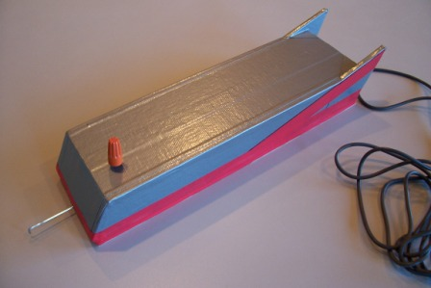
The MouseMobile

The Mousemobile and its PC host software demonstrate two unmodified mice used in the traditional manner (that is, upright on a table). One button is mechanically brought to the surface of the car for use as an input (the orange twist-on connector in the photograph), while the scroll wheels and other 5 buttons are not used. The author couldn’t resist; that classic DeLorean silver finish seen in the photograph is duct tape.

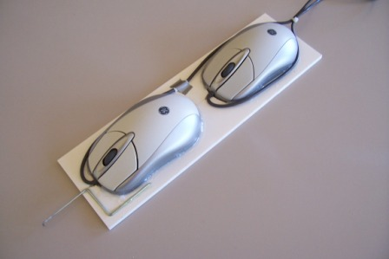
Inside the MouseMobile

One function the host software implements is simple tracking. A graphic on the screen shows the relative position of the MouseMobile as it is moved around and rotated. Clicking the button clears the display and resets the origin.

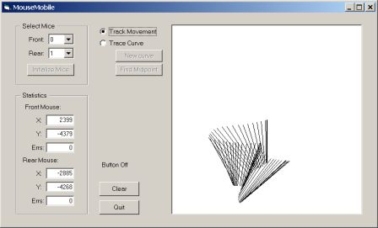
The MouseMobile being driven around Gotham City

An interesting lesson from this demonstration was that not only are mice coordinates not repeatable, but different mice report different displacements for the same distance. In theory every mouse counts a fixed number of units per millimeter (depending upon its setting), but repeated tests with the MouseMobile show that the front and rear mice did not agree on how far they moved, even with rotational issues resolved.

The MouseMobile has a pointer on it, so the software allows the user to trace a curve with the pointer and then guides the user to move the pointer to the midpoint of the curve. This isn’t particularly accurate in this demonstration because the software does not correct for the differing scales the mice use, the accurate position of the pointer relative to the two mice, or the relative positions between the mice themselves. All of these could be solved with a calibration procedure, but that was beyond the scope of this demonstration.

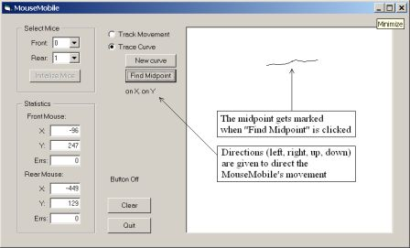
The MouseMobile finds a curve’s midpoint, more or less

Another thing that needs to be considered, especially when the optics are used on a surface of the end user’s choice (as is the case with the MouseMobile), is that optical mice perform erratically on certain surfaces. If they can’t see enough surface variation or are blinded by the intensity of the reflection, they lose their way and become as disoriented and confused as a college freshman on his first night out.

Mousitizer
The Mousitizer is a polar coordinate digitizer. While being even more impractical than the MouseMobile, it shows how the XY sensor can be used to measure angular rotation, and the scroll mechanism can be used to measure linear distance. The Mousitizer consists of a rotating platform upon which a sliding arm is attached. A pointer is at the end of the arm.

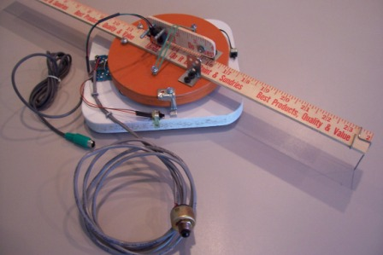
The mousitizer

As the orange platform rotates, mostly X displacement is detected (if the mouse circuit board were perfectly aligned radially with the platform’s center, theoretically only X displacement would be seen). There are two limiting switches (visible in the photograph at the bottom and right hand edges of the white mounting board) which are used for calibration. The third switch is brought out on a cable for use as a handheld input signal.

Unlike the MouseMobile, this unit required the humanitarian sacrifice of a mouse. Here’s what the alien autopsy revealed:

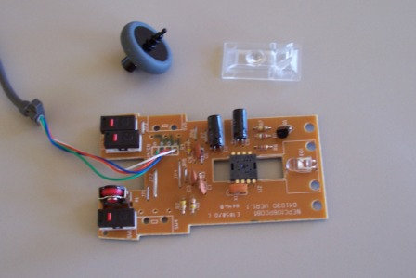
The GE scroll mouse: parts is parts

The three black rectangles on the left are the switches, the two button switches being on the top and bottom while the scroll switch (push the scroll wheel down to click) is second from the top. The device above the bottom switch is the scroll wheel input switch, a rotating low resolution device that receives the small end of the scroll wheel shown above the circuit board. The lens for the optics is next to the scroll wheel, and the optical IC (eye facing down) is in the approximate center of the photograph. The lens also channels light from the LED (far right) down under the optics chip to illuminate the field.

In the Mousitizer, the mouse circuit board was mounted upside down as shown in the photograph below. The switches and scroll wheel switch have been removed and wires connected to their PCB pads. The lens is in place in this photograph, and the rotating platform will be mounted above the optics. As the platform rotates, the optics will see its movement as (mostly) horizontal displacement.

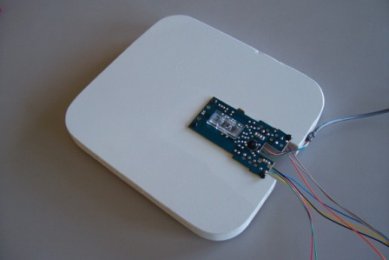
The Mousitizer’s leering eye looking up

Unfortunately the scroll wheel is a very low resolution device. To make matters worse, the design of all mice with scroll wheels is such that the wheel loses data if it is rotated too fast. Most users notice this when scrolling using the wheel. This happens because only 4 bits of scroll data are maintained, or 16 values, before the data is overwritten. In practical terms this means any device implementing the scroll wheel must necessarily move it relatively slowly (the mouse has no overflow/underflow indicator on the scroll wheel so data losses are unrecognized). In the Mousitizer this means that the sliding arm must not be hurried too much.

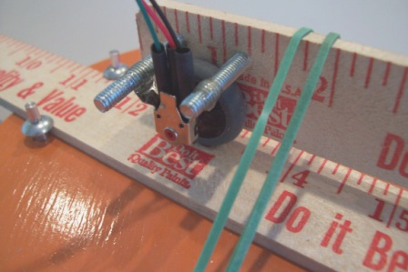
The Mousitizer’s scroll wheel measures linear distance.
The fine Corinthian Rubber tensioning device assures contact.

The low resolution of the scroll wheel switch made it impractical to actually get usefully accurate readings from the Mousitizer’s arm extension. If this were a real application the author would have used a second optical sensor on the sliding arm, but one of this device’s purposes was to demonstrate a possible use of the scroll wheel.

On this particular model of mouse, one revolution of the scroll wheel translated into 18 units of distance, or about 2.3 inches of Mousitizer pointer movement. Thus the resolution away from center (arm sliding in and out) for this fine device is about 1/8th of an inch. In contrast, for the platform rotation over 1,800 units were seen for about 90 degrees of travel which translates to about 0.02 inch resolution even when the arm is extended 18 inches. Of course this wood behemoth had far more wiggle inherent in its construction than that.

A more reasonable use of the scroll wheel in other applications would be the direct monitoring of the revolutions of a threaded screw since each rotation represents such a small screw displacement. Then the resolution of the scroll wheel would be quite sufficient, and speed overruns would likely not be an issue.

In writing the program to run the Mousitizer more unfortunate news came to light. The Mousitizer’s radial measurements (sliding the arm in and out) was quite stable and repeatable, but the rotational measurements were all over the place. There was very little consistency between measurements, much worse than with single mice or the MouseMobile. The mounting of the optics was modified since it was thought that perhaps the distance between the bottom of the platform and the mouse’s optics was incorrect. While this was probably true, it did not stabilize the measurements by an appreciable amount.

So the Mousitizer was fine in theory but failed in practice, and more experimentation was needed to isolate the specific problem. Again, the problem could be quickly solved using a non-optical mouse’s roller mechanism instead of the optical pickup, but that would also eliminate the scroll wheel and one of the switches. However, the X and Y axes on a non-optical mouse are independent, and one could be used for platform rotation and the other for arm extension. It’s a seditious thought, given that it was the lure of the optics that brought about this entire project.

The command language
The command language as implemented at the time of submission was functional but extensions for additional features were itching be added in the future (see “Improvements to the interface” below).

The desire was to keep commands as short as possible, which speeded things up but tended to make them terse. While it is possible but not expected that the interactions would be with a human at a terminal, terseness was not usually a problem. Commands are case sensitive.

Command | Example | Response | Comments
E or e | E | ack | Turn echo on (E) or off (e).
A or a | A | ack | Suppress (a, default) or enable  (A) leading zeros and sign  extensions on position output
0, 1, or 2 | 0 | ack or nak | Select active mouse
I | I | ack/nak | Initialize active mouse
S | S | ack/nak | Set the current mouse  position as the origin
X, Y, or Z | X | ###ack or nak | Read the current offset  from the origin
* | * | ##ack or nak | Get packet errors and overflows
xBtn, yBtn, or zBtn | xL  ym | ###ack  or nak | Read the saved offset from  when button last changed,  UC is H->L, LC is L->H
B | B | #ack  or nak | Read the switches  Bits: 00000LMR
PPort  pPortPin | PC  pD2 | ack or nak | Set port (P) or port/pin (p) to  input with pullups enabled
QPort  qPortPin | QA  qD0 | ack or nak | Set port (Q) or port/pin (q) to  input with pullups disabled
DPort  dPortPin | DB  dA1 | ack or nak | Set full port (D) or  port/pin (d) to output
WPortPin  wPortPin | WC6  wB1 | ack or nak | Write a zero (w) or  one (W) to a port/pin
RPort  rPort | RA  rC | #ack  or nak | Read high (R) or low (r) nibble from port’s PIN
TPort  tPort | TA  tB | #ack  or nak | Read high (T) or low (t) nibble  from port’s PORT
L...  (see below) | LMC13 | ack or nak | Lock a button to a port and pin in the specified mode
UBtn | UL | ack or nak | Unlock specified button

Naks are question marks (‘?’) and acks are exclamation points (‘!’). Naks are sent for invalid commands, bad values, mice that don’t exist or are unititialized (for most mouse commands), and the like. If echo is on (default is off), each character received is returned, and acks and naks are followed by CRLF, thus making terminal based interactions more user friendly.

Returned values (‘#’ in response column of table) are in hex. A single # means one hex digit, two (##) means two hex digits, while three (###) indicates one to six hex digits if suppression is on (default). In this case leading zeros are omitted, and the leading ‘F’ values on negative (2’s complement) numbers are replaced with a single minus sign. Suppression off (‘A’) causes all position values to be sent as 6 digit (24 bit) 2’s complement hex numbers.

Packet errors and overflows (‘*’) return an 8 bit number formatted YX######. Y and X are mouse overflow flags passed on from the mouse and indicate that internally the corresponding mouse movement exceeded 9 bits before the mouse could send out its packet. For a relatively low resolution sampling rate this should not occur. The low order 6 bits are the number of packets that have been rejected for timing or content errors and indicate lost data (in the current software). The number stops incrementing at 63. Reading these values resets all three error values to zero.

Ports are A to D, pins are 0 to 7, and buttons are L, M, and R. Some care should be exercised (i.e., don’t) when writing to mouse clock and data pins or changing their direction.

When reading or writing directly or indirectly (via locks) to pins, it is the host’s responsibility to ensure that the direction of the pin has been correctly configured. No automatic configuration takes place, with the exception of the mice clock and data pins.

The host may read either the AVR PORT values (T/t command, what was written to the pins) or the PIN values (R/r command, the signal actually present at the pin). Typically the PIN values are what the host will be interested in, but both are included for completeness.

The Lock command (L) needs further explanation. A button (switch) can be associated with an AVR pin, so that when the status of the button changes the pin can change as well. Once set up, this happens independently of the host.

The L command specifies the button, port, pin, and the mode in that order. Currently implemented modes are:
0 unlock (default, no association to any pin)
1 reflect (pin is 1 if button is pressed, 0 otherwise)
2 invert (pin is 0 if button is pressed, 1 otherwise)
3 toggle (pin toggles when button changes)
4 toggle on click (pin toggles when button is clicked)
5 toggle on release (pin toggles when button is released)

Setting the mode to 0 for a button (using any port or pin) breaks the connection, and is functionally identical to the U command.

Evaluation of returned position data when suppression is on is easier than it might look. If the first character is not a minus sign, simple hex conversion yields the correct value. If it is a minus sign, the remaining hex digits represent a 2’s complement number requiring leading sign bit extension. To evaluate, convert the hex number and then subtract 16 to the power the number of characters remaining. This will result in the correct negative number. For example, -F yields 15 (the F) minus 16^1 (or 16), or -1. Likewise, -FF (although this would not be returned by the interface) yields 255 (the FF) minus 16^2 (or 256), or -1. It works for all other patterns as well. Of course, if the host is being programmed in a bit friendly language, it is a simple matter to just perform the sign extension and be done with it.

Improvements to the interface
This version of the interface has shortcomings, partly because of time constraints, and partly because this is entertainment, not a master’s thesis.

The recovery for mouse communication errors should be more robust and include requests for retransmission of bad data. Mice understand a resend command, and will retransmit the most recent packet. The assumption was that bad packets and transmission errors were rare, and the request error count command (‘*’) was added to see if this were true.

The interface and command language could be extended. Features which were contemplated but left out in this initial version include:

Adding pulsed I/O as a command and locked pins option, so that a pulse of specified polarity and duration could be generated. While pulses can be effected with the current commands, there is little control over pulse duration because of the communication overhead between starting and stopping the pulse.

Adding PWM as a command and locked pins option, so that events and/or the host can trigger pulse trains.

Allowing button events to be locked to multiple AVR pins using independent modes.

Adding axis offset crossings in a manner similar to the button events for locked pins. For example, when the current mouse X position falls with a specified range, any of the events tied to buttons could be triggered.

Implementing other features of the AVR such as the A/D converter, two wire and SPI interface, analog comparator, and unused timer/counters so they are available to utilize with external hardware via the interface.

Allowing data to be read from and written to the AVR’s 512 byte EEPROM, including saving and executing command strings. This would allow maintaining nonvolatile calibration data, among other things.

Allowing the host to control various mouse initialization parameters such as resolution, sample rate, and the like. Currently these are hard coded.

Allowing the host to set port and pin assignments for the mouse data pins. Currently these are hard coded. The clock pins are fixed since they are the external interrupt lines (int0 – int2).

Another contemplated feature was support for the PS/2 keyboard. Other than data stream content, the PS/2 mouse and keyboard interfaces are identical. Consequently it would be possible, with fairly minor software changes, to support a total of three mice and/or keyboards with this interface. Keyboards are also available for under $10. Some truly goofy things, like a 300 key electric piano, could easily be built, but, in the sagacious words of Richard Nixon, “it would be wrong.”

There is currently a small potential problem with mouse initialization. When power is first applied to a mouse it performs diagnostics and sends a couple of status and identification bytes. This follows a delay of a second or so, and documentation highly recommends that there be no communication to the mouse prior to receiving at least the first of these two bytes. However, the interface has no way of knowing whether its mice have just powered up or not (unlike a PC’s POST routine), so requiring the bytes prior to performing an initialization is not an option. One solution is to always wait a second or two prior to initialization, another would be to watch for the bytes, utilize them if present, and wait if not. The approach taken by this version of the interface is to document the situation (you’re reading it) and let the author of the host software worry about it.

The bottom line
But what did the author learn from such a wondrous beast? The thing that sticks in mind the most, probably because of the time spent vs. the stupid factor, is that the inc instruction doesn’t set the carry flag. Other than that, he learned all sorts of things about mice, AVR architecture, design compromises vs. timelines, and expectations vs. hard (and hardware) realities. And that life would be easier with a logic analyzer.

The good news is that the author has the interface he wanted and will continue to tweak it. The bad news is that it doesn’t have the accuracy he hoped for, although a quick look at his duct tape and plywood creations would indicate accuracy is not typically his highest priority.

A good time was had by all.

Block Diagram

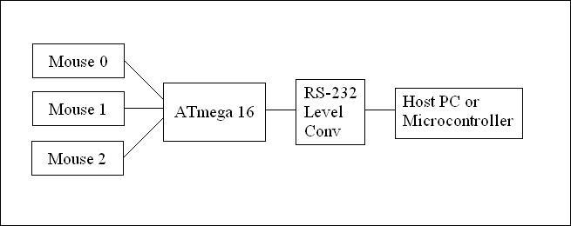

The interface supports 3 mice.
The MouseMobile demonstration uses 2 unmodified mice.
The Mousitizer demonstration uses 1 mouse which has been disassembled and parts strewn asunder.

Schematic

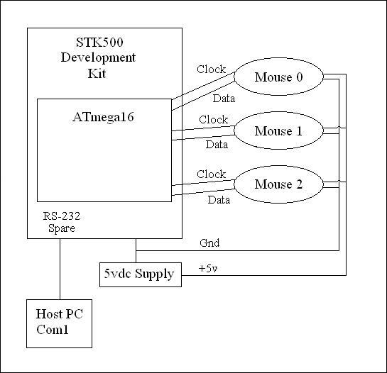

Circuitry added to STK500:
3 mice & PS/2 connectors
External 5vdc power supply

Mice connect to the ATmega16 through the STK500 port connections:
Mouse 0 clock Port D, bit 2 (Int 0)
Mouse 0 data Port D, bit 4
Mouse 1 clock Port D, bit 3 (Int 1)
Mouse 1 data Port D, bit 5
Mouse 2 clock Port B, bit 2 (Int 2)
Mouse 2 data Port B, bit 0

Other STK500 connections:
Spare RS232 Tx Port D, pin 0 (TxD)
Spare RS232 Rx Port D, pin 1 (RxD)
LEDs Port C
Switches Port A

